Data Ethics in Our 17 year long history

At Quantium, we believe that data is the behavioural footprint of humanity and that it has to be treated with the utmost care and responsibility. Histories, attitudes, indeed lives are stored within it in ways that aren’t always apparent – and that’s what makes its potential so powerful. To work with it responsibly, sensitively, we set ourselves the highest data privacy protection and governance standards. We have spent 17 years perfecting privacy-by-design and secure-by-design principles. Central to this is not holding any personally identifiable information about people – we neither receive it, and put the necessary protections in place to be unable to decipher it.

Every aspect of handling data is safeguarded: from its de-identification to its encryption – data security is paramount and of the highest grade. We pride ourselves on gaining the trust of iconic organisations around the world through years of securely working with their data, and in turn the trust that builds with their stakeholders.

Executive Summary

From task 1, we saw that the sales increase in the month of December before the Christmas (except the day itself). So, these are the crucial times. Next, we observed that Kettle is the most popular brand followed by Smiths, Doritos and Pringles. So, they need to be in stock. Also 175-gram packets are the most sold. Mainstream young singles/couples, retirees are the most common customers and account for a great share of chips sale. Older families that budget heavily on food have the maximum contribution to sales.

Continuing onto task 2, One control store was selected for each trial store and the values of metrics were compared in trial and pretrial period. The results for trial stores 77 and 88 during the trial period show a significant difference in at least two of the three trial months but this is not the case for trial store 86.

Customer Analysis

Sales Distribution - The sales have a sudden hike n the month of December before the Christmas (except the day itself). Whereas there is no sales on 25th

Affluence and the effect on consumers purchasing chips

By visualising the proportion of customers by affluence and life stages on this graph, we can see that mainstream young singles/couples, retirees are customers contributing the most.

In the distribution of life stage customers, it can be seen that that retirees, young singles/couples, retirees are the most common customers.

From the average expenditure per segment category, we can observe that mainstream young singles/couples also spend the most.

Popular Brands

Kettle is the most popular brand followed by Smiths, Doritos and Pringles.

Trial Store Performance

The correlation of the control store 77 versus other stores shows that stores with maximum similarities have the highest correlation. So stores 233, 119 and 79 are the most correlated.

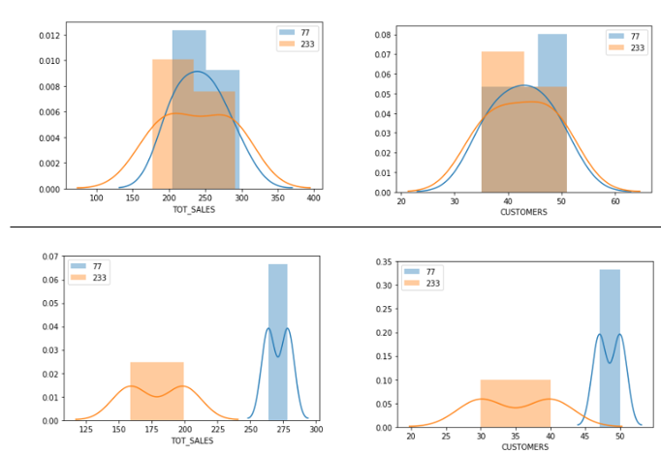

The correlation of the control store 86 versus other stores can showcase that stores with maximum similarities have the highest correlation. So stores 233, 119 and 79 are the most correlated.

In trial store 68 and Store 155; 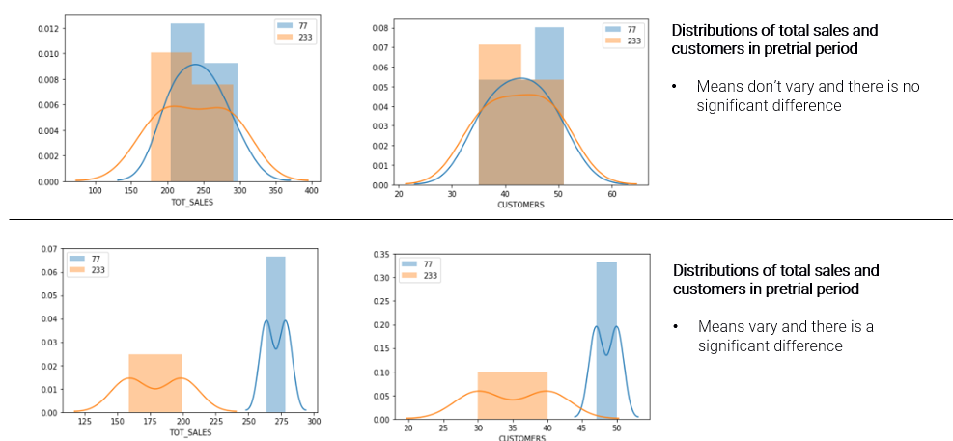

Correlation of store 88 vs store 237

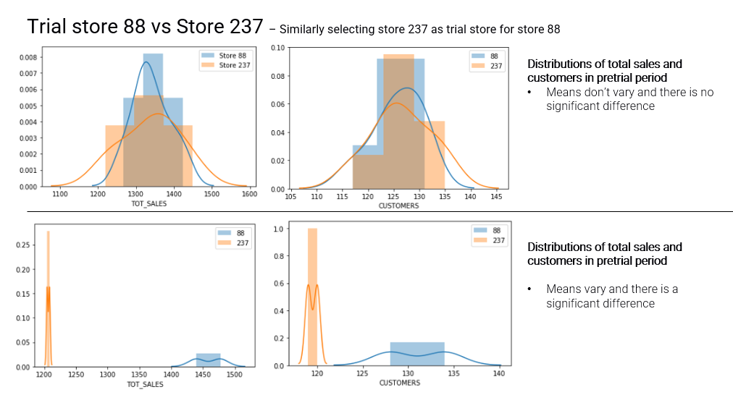

The control store were set up to measure sales whether trial store are doing better during the trial period or not.

Conclusion

We've found control stores 233, 155, 237 for trial stores 77, 86 and 88 respectively. The results for trial stores 77 and 88 during the trial period show a significant difference in at least two of the three trial months but this is not the case for trial store 86. We can check with the client if the implementation of the trial was different in trial store 86 but overall, the trial shows a significant increase in sales.

Recommendations

Stocks should be high in December before the Christmas. Kettle, Smiths, Doritos and Pringles should be kept in stocks as they are the most sold. Mainstream young singles/couples, retirees are the account for a great share of chips sale so they need much attention. Budget older families have the maximum contribution to sales. Control stores 233, 155, 237 for trial stores 77, 86 and 88 respectively would be a good choice.